University of New England
English 122—College Reading and Writing I
Fall 2018 * M/W/F * 2:00pm—2:50pm * Decary Hall 210
Section D
Course Syllabus

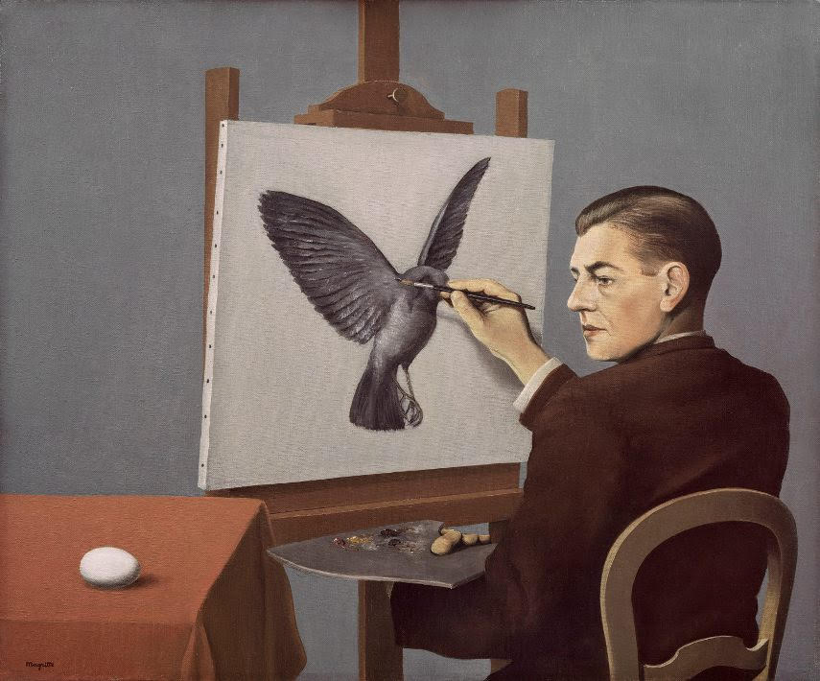

Clairvoyance by René Magritte, 1936.

Instructor: Mr. Jesse E. Miller
Office Hours: Marcil 106; Office Hours: Mon./Weds.- 11:00-12:00; Fri-10-11 and 1-2; and by appointment.

Email: jmiller.une@gmail.com
Phone: 207-602-2871. Office: 106 Marcil Hall

Our Course Site: https://miller-eng122.uneportfolio.org/

Required Textbooks and Materials:

Bullock, Richard, Michal Brody, and Francine Weinberg. The Little Seagull Handbook. 3rd ed. New York: W.W. Norton, 2017. (ISBN: 978-0-393-60263-0)

Graff, Gerald, and Cathy Birkenstein. They Say, I Say: The Moves that Matter in Academic Writing. 3rd ed. New York: W. W. Norton, 2014. (ISBN: 978-0-393-93584-4)

Miller, Richard, and Ann Jurecic, Habits of the Creative Mind. Boston: Bedford/St. Martin’s, 2016. (ISBN: 978-1-4576-8181-3)

*A folder to collect major assignments for the portfolio *A composition notebook for notes.

Note: Some of the readings will be handouts, which I will provide. Treat these as vital texts—collect our readings in a binder or folder, for the works we’ll be reading throughout the entire semester will be revisited.

Course Description and Objectives:
This course is the first part of a two-course sequence that is equivalent to English 110, English Composition. The course begins students’ introduction to writing as a conscious and developmental activity. Students learn to read, think, and write in response to a variety of texts, to integrate their ideas with those of others, and to treat writing as a recursive process. Through this work with texts, students are exposed to a range of reading and writing techniques they can employ in other courses. Students work individually and collaboratively, participate in peer review, and learn to take more responsibility for their writing development. Students enrolled in the course must also register for SAS 011, Engaging with Text Writing Lab, a one-credit lab that supports work in ENG 122. Placement into this course is determined by entering SAT (or ACT) writing scores. Co-requisites: SAS 011. 3.000 Credit hours.

Special Note Regarding SAS 011: Students enrolled in ENG 122 must also be enrolled in SAS 011, Engaging with Text Writing Lab, an individualized, student-support course that works in tandem with ENG 122. If your current class schedule does not include SAS 011, please see someone in the Student Academic Success Center to get registered for the course. If you drop SAS 011, you will be dropped from ENG 122.

Evaluation in ENG 122

Your course grade is determined by the level of fluency you demonstrate on the 7 course learning outcomes. Throughout the course, you will collect, interpret and present evidence of your developing fluencies.

In this course, evidence of fluency can take the form of reading notes, prewriting, working drafts, revision plans, work logs, sample paragraphs or sentences, and much more. A final paper is one among several pieces of the evidence of your fluency.

In one-on-one meetings with me, you and I will discuss this evidence, gauge your progress on course learning outcomes and make a plan for improvement.
This form of grading and assessment empowers students to take responsibility for their learning and rewards them for growth and learning over time, rather that creating a few high-stakes moments of performance

Learning Outcomes:
- Demonstrate some ability to approach writing as a recursive process that requires substantial revision of drafts for content, organization, and clarity (global revision), as well as editing and proofreading (local revision). | 15% of final grade
- Begin to effectively integrate their ideas with those of others using summary, paraphrase, quotation, analysis, and synthesis of relevant sources. | 15% of final grade
- Employ techniques of active reading, critical reading, and informal reading response for inquiry, learning, and thinking. | 15% of final grade
- Demonstrate growth in their ability to critique their own and others’ work by emphasizing global revision early in the writing process and local revision later in the process. | 15% of final grade
- Reasonably document their work using appropriate conventions (MLA). | 5% of final grade
- Control individualized patterns of sentence-level error (grammar, punctuation, spelling). |5% of final grade
- Demonstrate some of the work habits and attitudes of an engaged learner. | 30% of final grade*

*Engagement (30%)

Students demonstrate strong engagement by

Attending class, paying attention, and participating
Embracing practice and work as keys to learning
Trying new approaches and taking risks
Persisting in the face of struggle, challenge, and error
Seeing mistakes as opportunities for reflection, learning, and growth

Final Grade Range

A = 93-100
A- = 90-92.9
B+ = 87-89.9
B = 83-86.9
B- = 80-82.9
C+ = 77-79.9
C = 73-76.9
C- = 70-72.9
D = 60-69.9
F = <60
I = Nearly all work completed; fewer than 4 absences
WP = Withdrawal while passing after first two-thirds of the term
WF = Withdrawal while failing after first two-thirds of the term
W = Withdrawal during first third of the term

Attendance and Tardiness:
Attendance is required. You may miss FIVE classes without penalty (though missing any class time will certainly diminish your potential for success). However, should you miss a SIXTH, it is highly unlikely that you will pass my class. I am not a dictator and I realize life has its hiccups, however this is a concrete rule.

As the great Bill Hicks puts it: Tardy is one of those words that means absolutely nothing in the real world. I hope you realize that. If you don’t realize that, trying showing up late to work tomorrow with:

YOU: “Hey, sorry I'm tardy”
BOSS: “Hey, sorry you’re fired.”

Please be on time for each class. Three “lates” equals one absence. It will behoove you to let me if you know you are going to be late. All missed work we do in this class is your responsibility.

Perhaps unlike any other you’ve had before, this class is as much a product of your involvement and contributions as much as mine. I promise to teach with my whole self. In order to earn maximum points on your Citizen of this Class grade, you will need to do the same.

Disruption Policy:
If you must bring your cell phone to class, please set it to vibrate or SHUT IT OFF. Please KEEP YOUR PHONE OUT OF SIGHT. Disruptions to the class will not be tolerated. You will not text during this class. You will not make or receive phone calls during class. Please stop trying to hide your phones in your laps. I can see them! And what’s worse, that kind of covert practice most assuredly makes you a bad person, if not an anti-intellectual. Also, be courteous and respectful to the class when coming and going. PLEASE do not start packing up your materials until class has ended.

Please do not get up during class to throw out your trash. This isn't your dorm room, bedroom, or living room. Comport yourself as the courteous adult you either already are, or are aspiring to be!

External discussions and chatting during my class will not be permitted. I will eliminate unwanted talking by first addressing the problem with you. The second step could be to change your seat. Lastly, if the issue keeps up, you will leave my classroom. I reserve the right to assign seating arrangements at any time during the semester.

Significant Assignments

Ongoing smaller projects including PLT (Paper-Like Things), Artifacts, Post-Conference Reports, and Field Notes.

1) PLT Week 2-10
2) Artifacts Week 2-10
2) Post-Conference Reports Week 6; Week 14-15
4) Field Notes (5) Week 2-12

Due dates are subject to change, and quite honestly, please consider this a very tentative listing. It’s important to attend class and visit the course site regularly to remain alert to changes. Detailed writing prompts and guidelines will be provided.

Field Notes:
Pick 5 of these to complete throughout the semester, no more than one per week:
- Visit a professor in major or area of interest in an office hour – interview them about the role of reading and writing in the profession
- Visit a professor in an office hour to talk about an assignment/concern in a class you’re taking
- Attend a SASC “how to study” or test prep workshop or have a Learning Specialist Consultation
- Book and keep an appointment with a SASC tutor
- Interview and profile a former Stretch student– what made them a successful student?
- Interview and profile a fellow student you admire as a student – what makes them a successful student?
- Attend an Center for the Global Humanities event on Portland Campus – bonus points for asking a question
- Find an online magazine or podcast that thinks things through and read/listen to something (check with me first)
- Read this article about JD Martinez and without too much prompting from me, help me understand how his process and practice might be in conversation with our work in ENG 122.

For each one you select, distill your experience in a short essay. Time-on-task of writing (not including the event) should be 1 hour. Be sure post your short essay on your ePortfolio under a page labeled “Field Notes.”

Field Notes, Artifacts, and other experiences will be stitched together toward the end of the term to form a significant writing project.

Resources for Academic Success

Contacts
Please share your name and contact information with two other members of the class. It is your responsibility to remain up-to-date and informed of our daily activities and of any changes made to the readings or assignments. If you have missed a class, you should consult the syllabus on the course site and/or your contacts to find out what you need to do.

How to Contact Me

My office hours and telephone number are listed at the top of the syllabus. Please feel free to stop by during those hours to discuss assignments, class discussions, etc. If you want to be certain that I will be available, however, it never hurts to schedule an appointment. It is generally easiest to reach me by email, but please do not expect me to be “on call.” I generally do not check email in the evening, so please do not expect a response until the next day. Note that I will not comment on drafts of papers the night before they are due.

Academic Integrity (Including Plagiarism) Statement
This course is an important introduction to college-level reading and writing. As an emerging college-level writer, you will develop your ability to read responsibly and critically, to work with texts appropriately, and to write in ways that are valued and respected within the community. We will conduct ourselves with integrity by doing our own work, by acting as responsible peers in (and out of) class, and by working with sources in ways appropriate to the academic community of which we are a part. It is understood that we are learning to work within the norms of our community, and so we will work on these matters.
Students enrolled in English 110 are strongly encouraged to take a few minutes to complete the nationally recognized Academic Integrity 101 Self Test to familiarize themselves with the issue.
http://www.une.edu/studentlife/plagiarism/self-test

UNE has a clear policy on academic integrity and a multi-step procedure for addressing cases of suspected academic dishonesty. Both the policy and the procedure are distributed as a two-page handout at the beginning of the term. They are also available on the UNE website under the Academic Integrity Policy (Student Handbook, p. 47) and the Procedure for Reporting Alleged Academic Dishonesty.
In our class, the policy applies to all of our work, from homework to formal papers. The policy does not inhibit robust collaboration.

Midterm Academic Progress Reports
The University of New England is committed to the academic success of its students. At the midterm of each semester, instructors will report the performance of each student as SATISFACTORY (S) or UNSATISFACTORY (U). Instructors will announce when these midterm academic progress reports will be available for viewing via U-online. This early alert system gives all students important information about progress in their courses. Students who receive an UNSATISFACTORY midterm report should take immediate action by speaking with their instructor to discuss suggestions for improvement such as utilizing the services of academic advising, the Student Academic Success Center, Counseling Services, and Residential Education.

Student Academic Success Center
The Student Academic Success Center offers a range of free services to support your academic achievement, including tutoring, writing support, test-prep and studying strategies, learning style consultations, and many online resources. To make an appointment for tutoring, writing support, or a learning specialist consultation, go to une.tutortrac.com or visit the SASC. To access our online resources, including links, guides, and video tutorials, visit https://une1.sharepoint.com/sites/SASC.

Access for Students with Disabilities
The University of New England is committed to creating a learning environment that meets the needs of its diverse student body and will make reasonable accommodations for students with documented disabilities. Any student eligible for and needing academic adjustments or accommodations because of a disability is requested to speak with the professor at the beginning of the semester. Registration with the Student Access Center is required before accommodation requests can be granted. Visithttps://www.une.edu/student-access-center for more information.

Academic Calendar

WEEK 1

WEEK 1—Orienting
Wednesday, Aug. 29
1. Introductions
2. Syllabus
3. The expectation in this class is to check your email each day during the week.

Assignment:
1. Read : “Letters to Students” in Habits. Going forward, when you read from Habits for now on: Underline at least two but no more than three short passages on each page that seem important or surprising to you, or about which you are curious, or which present a new idea about writing to you. Be prepared to discuss the passages you underlined with classmates. Single-tasking time-on-task: (20 min)
2. Journal: In 30 minutes:
What is meeting half-way?
What is the philosophy of habits?
What is reflection? How might assembly differ from the creation of a full-length written project? How does this reading fit with your prior experience? How do you feel about this approach?

3. Look for email from UNEportfolios.
4. Take no more than 5 minutes to skim this reading (by skim I mean, quickly read two or three paragraphs, skip two or three, read a couple more, skip a couple more) and 5 more minutes to review this college-level writing assignment, then take 10 minutes to answer the questions in this anonymous survey about your high school reading and writing experiences.
Bring CHARGED computers to class next time, and always.

Friday, Aug. 31
1. Journal playback
2. ePortfolio
Log in
Create menu
Create Journal page. Post Journal 1 AND post on our course site in the designated spot. This is how you earn credit.
Create page: Artifact # 1 (for next week)
Begin to make it your own: resources here.
3. Engagement card.

Assignment:
Artifact # 1: Write a narrative about your life as a HS student
What were your habits, mindset, dedication, approach?
Were you passed along? Did you try hard? Were you rewarded for easy work? Try to reflect as honestly as you can for this narrative.
Spend some time looking for and include a final draft of a writing project from high school* (last 2 years). What are your thoughts about this project with a little remove?
Come with a draft of 300 words on Weds. 60-90 min
*entry essay?

